**Personal Portfolio 2**

Group 70 – Team S.K.R.A.M

Ruoxuan Zhang (Mike) – n9620176)

GitHub ID: Mmmmmmmike

GitHub email: zrx724548549@gmail.com

**Artefact 1** – UI design of one new webpage & UI design improvements.

**Description about what the artefact is in general**

The UI design is an essential process of creating website interfaces, it can help developers implement the back-end functions of web pages conveniently. The purpose of the UI design is to collect pros and cons from users and understand their user experience so that the company can directly fix issues at the early beginning and it can improve the quality of future implement.

**Brief description of how it was used/contribution to the project**

In our sprint 2, the IS students are required to design new webpage interface for web pages which have not been finished in sprint 1. My task is to design one new web page which is called User landing page. How they were used in our project is that users will be able to edit their personal information which is also one of our “must” user stories. Although I have done some designs and HTML in the sprint 1 for other pages, I’m still not confident about my programming skills. Therefore, the UI design of the new page could give me an early version of the website interface, then I could just follow the design to create the CSS with its HTML codes.

After the group discussion, some of my design and HTML works need to be improved, the reason is that one of our CS students found out his PC screen resolution is different to my PC, lots of designs and HTML CSS cannot be showed correctly on his screen, therefore, he wants me to change the layout, font size, colours, shapes, etc. Also, my tutor stated that there were lots of unnecessary information in some of my pages such as store locations. This can be found in the screen capture.

**Screen capture of where it’s used**

**Design of User landing page**

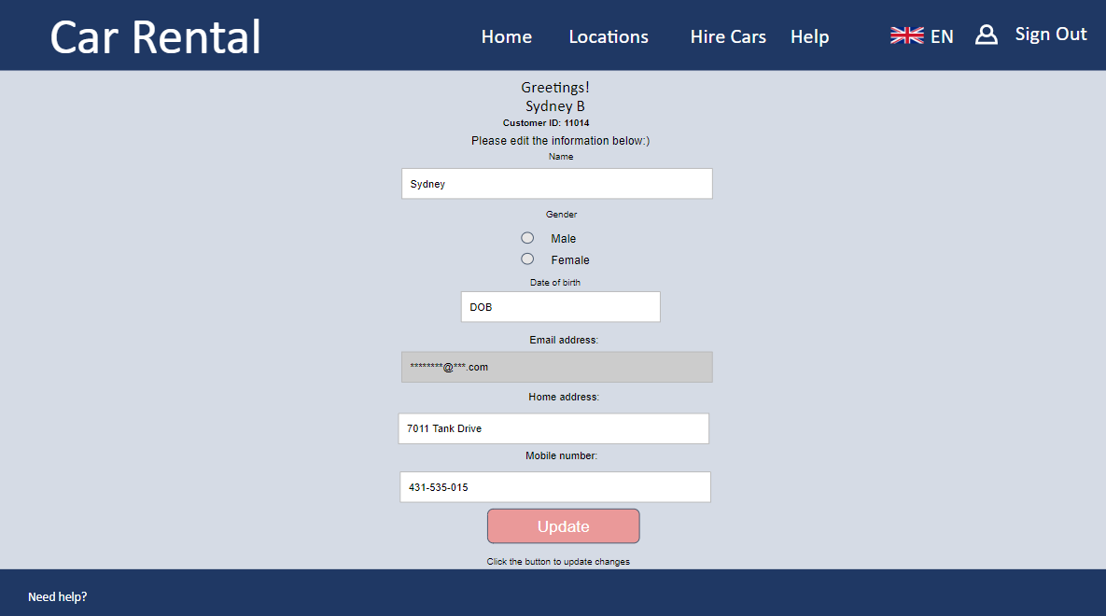

**Contacts us page used to be like**

**A screenshot of a cell phone

Description generated with very high confidence**

**Improved Contact us page**

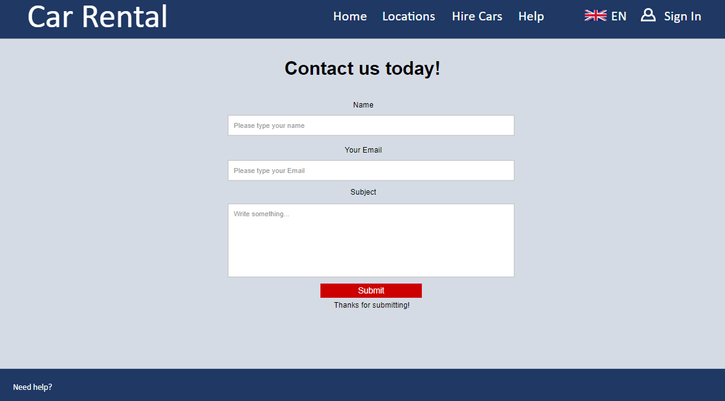

**Artefact 2** – Implement the UI design to be the html coding of one new page & Improved three existing pages.

**Description about what the artefact is in general**

To implement the UI design, the HTML and CSS coding is necessary. The HTML is a website development language that can let the developer create webpage elements. The CSS is like a formatting file, it formats the structure, positions, and technical functionalities. The coding artefact represents how we make the UI design to be the real web page.

**Brief description of how it was used/contribution to the project**

In our sprint 2, the IS students are also required to use HTML and CSS to implement more webpage interfaces for each new page. My task is to create the user landing page and improve the Contact us page, show car information page and staff home page. However, there are issues with the Staff homepage and show car information page, which is done by other group members. The reason is that other members had tasks to edit webpage which is done by me, same as them, I also have tasks to edit web pages which are done by them. It is because, in the final demo, our CS team intended to add more features in existing pages, for example, they added a google map in my car return page. Therefore, the screenshots which I put in this document will be different to the final demo because other people added more features in my original webpage. For my webpages which were edited by other people, I will not put in my artefacts because those are their works, so, I only put my own edit pages and original page as you can see below.

**Screen capture of where it’s used**

**(Overview of user landing page)**

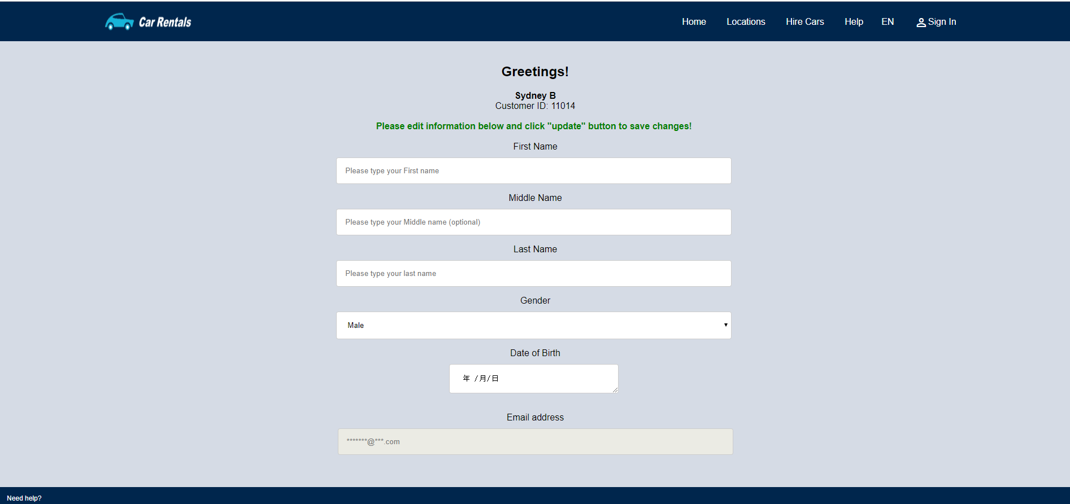

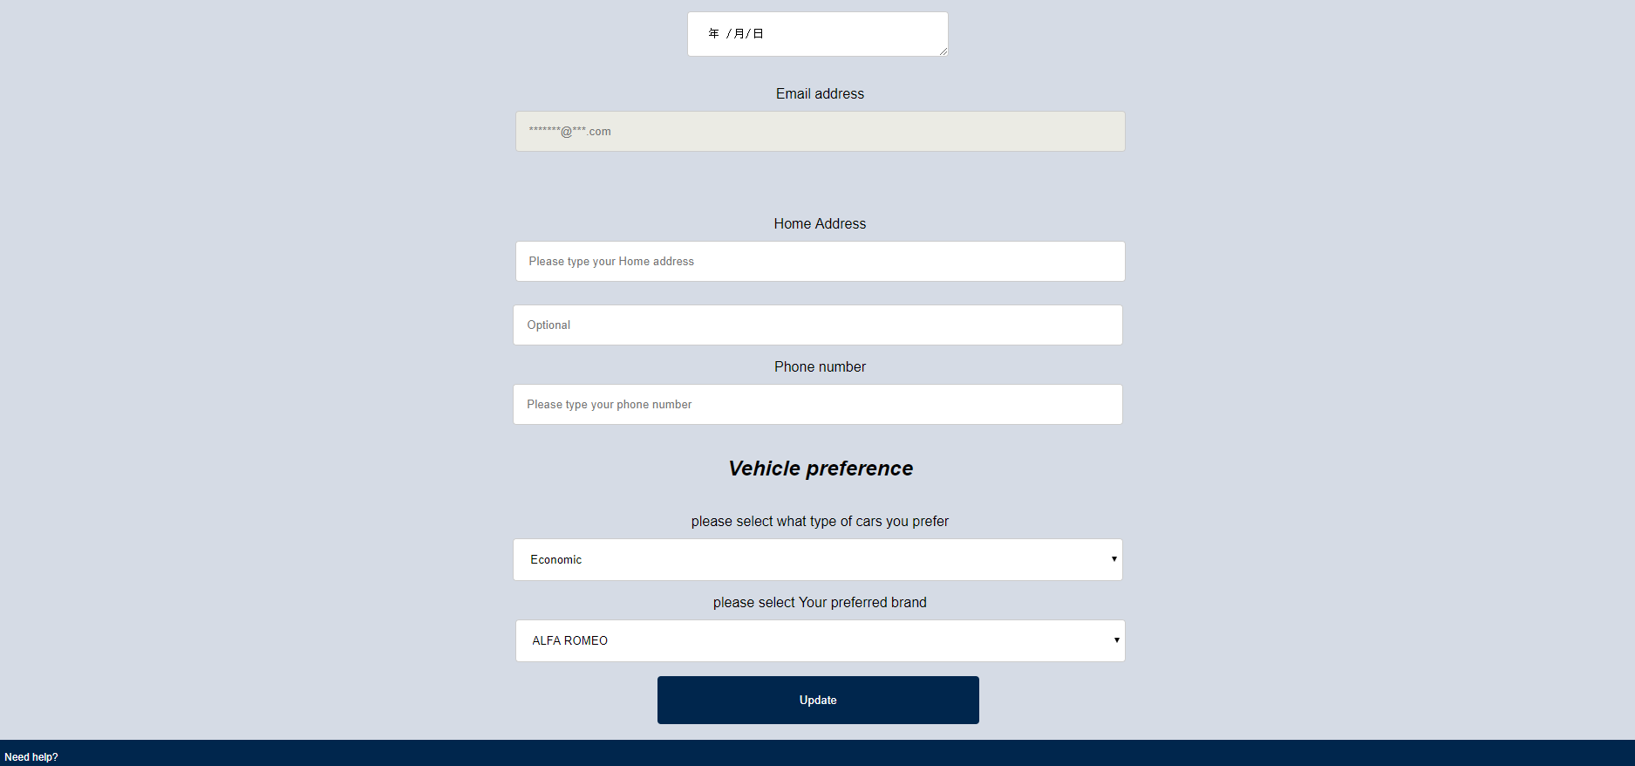

**(Html)**

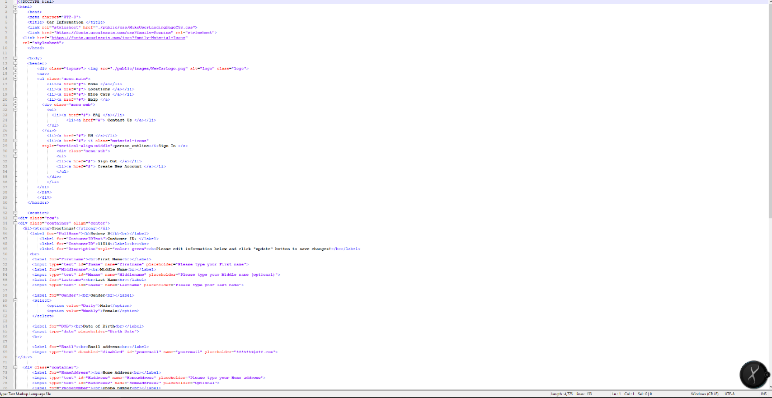

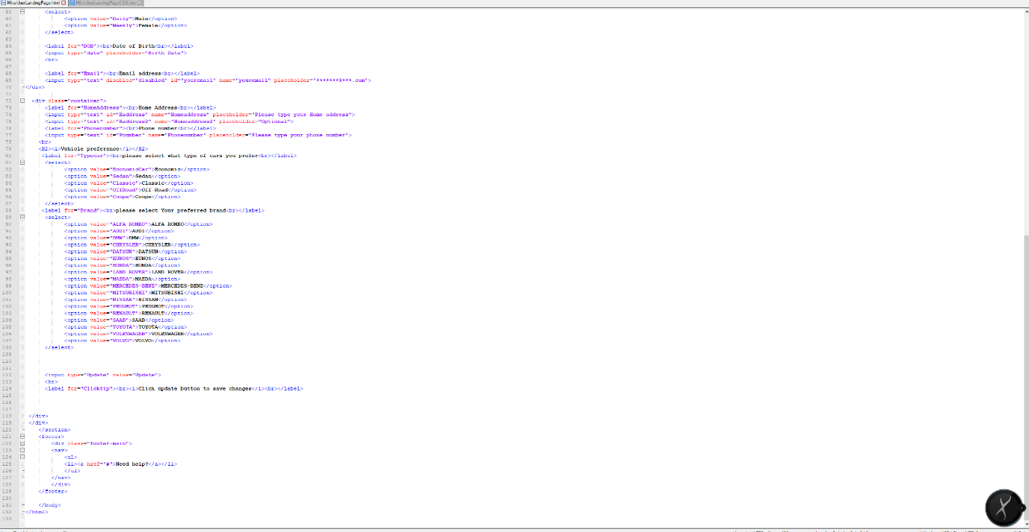

**(CSS)**

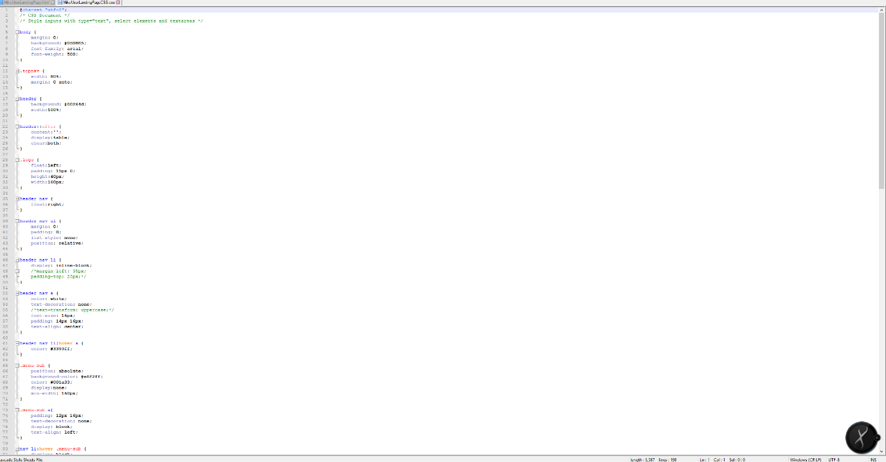

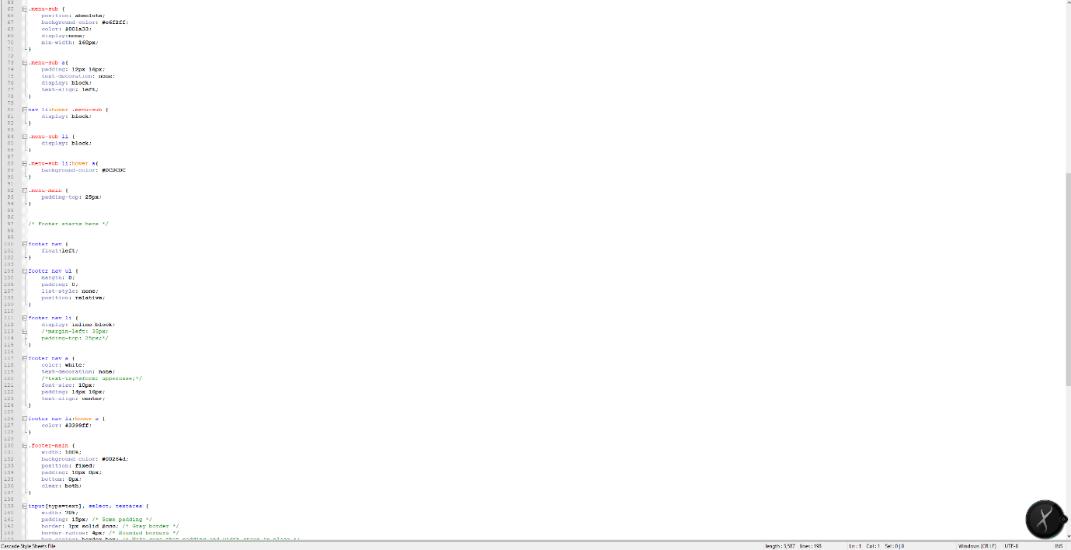

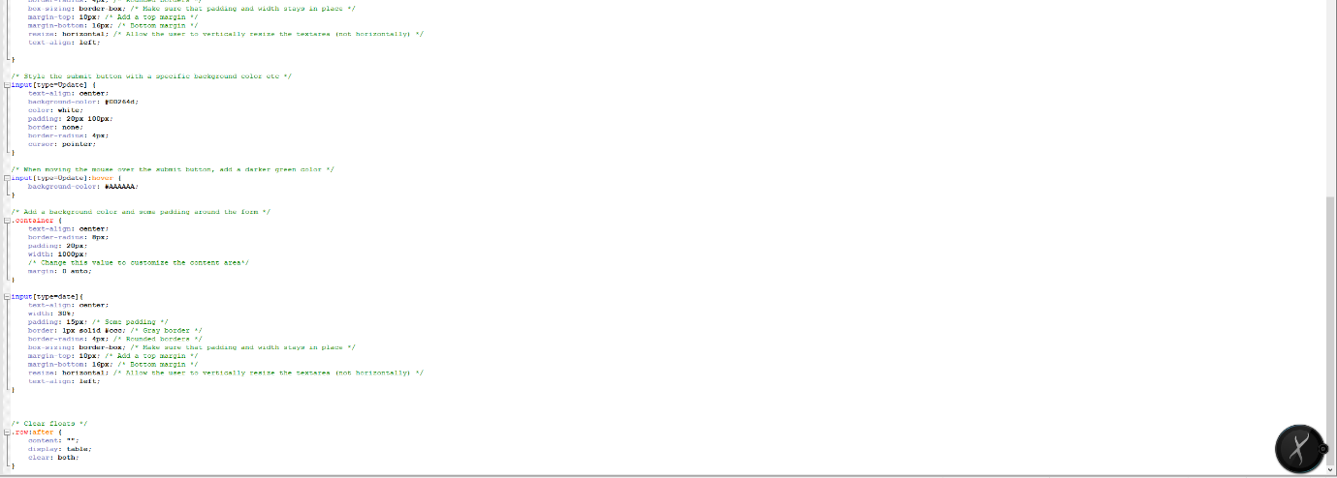

**(Overview of new contacts us page)**

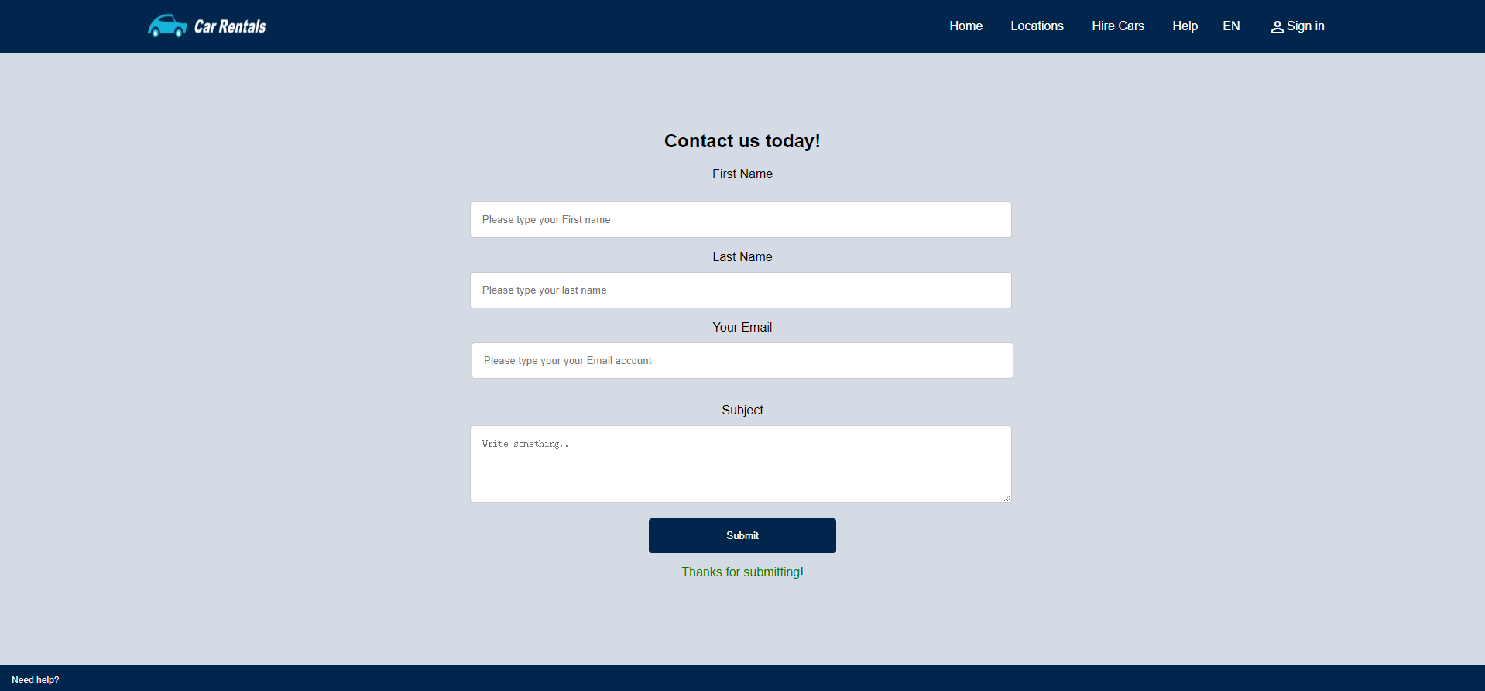

**(HTML)**

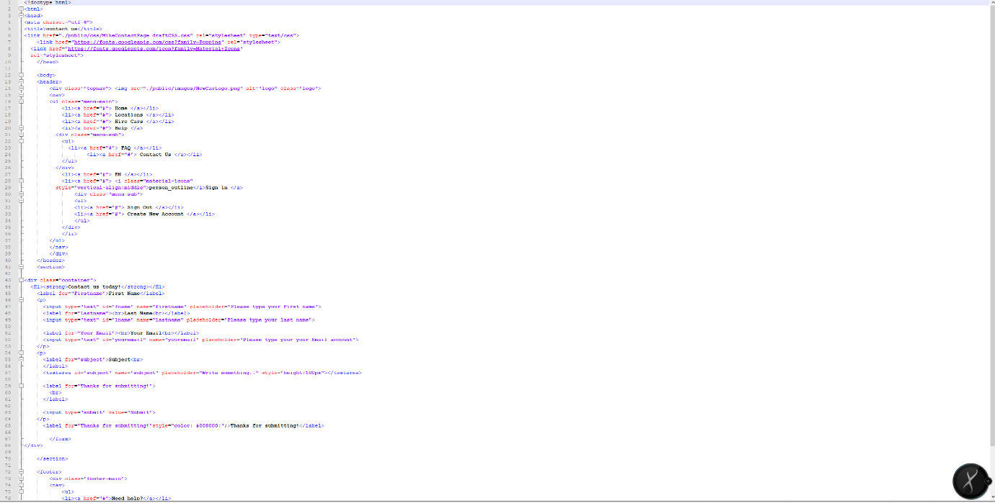



**(CSS)**

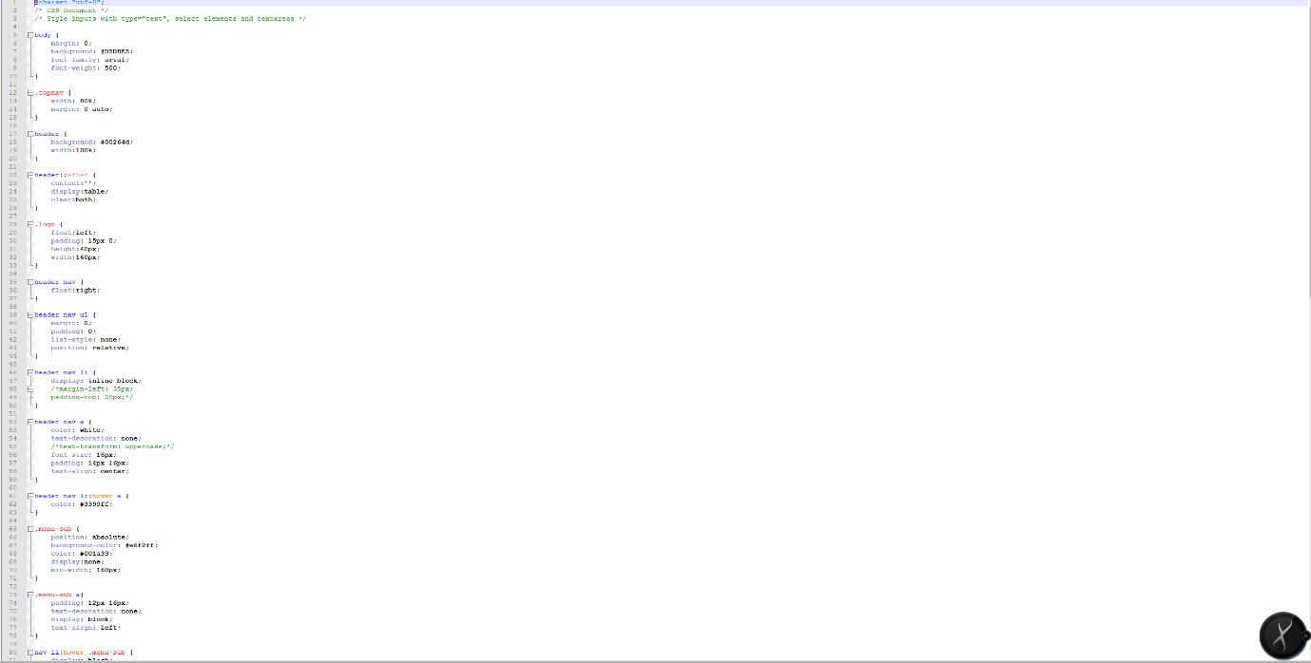

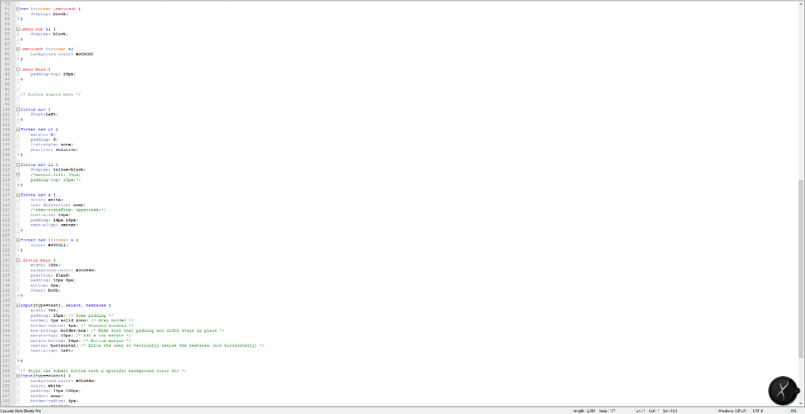

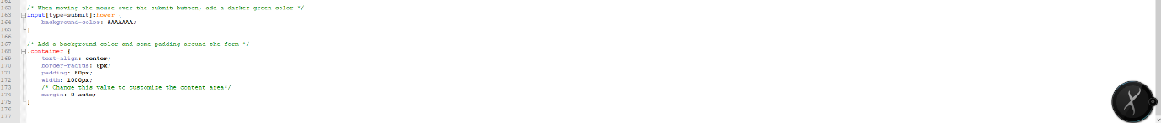

**(my version of staff homepage html and CSS, Improved button style and highlighted the button that we implement, it can absorb the makers attention)**

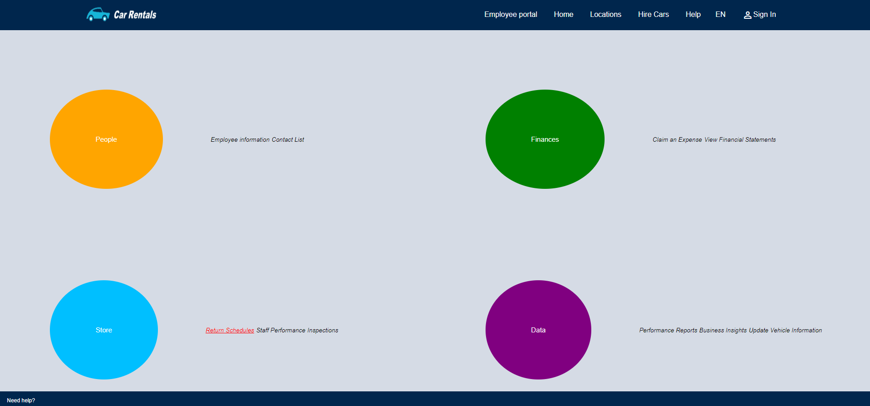

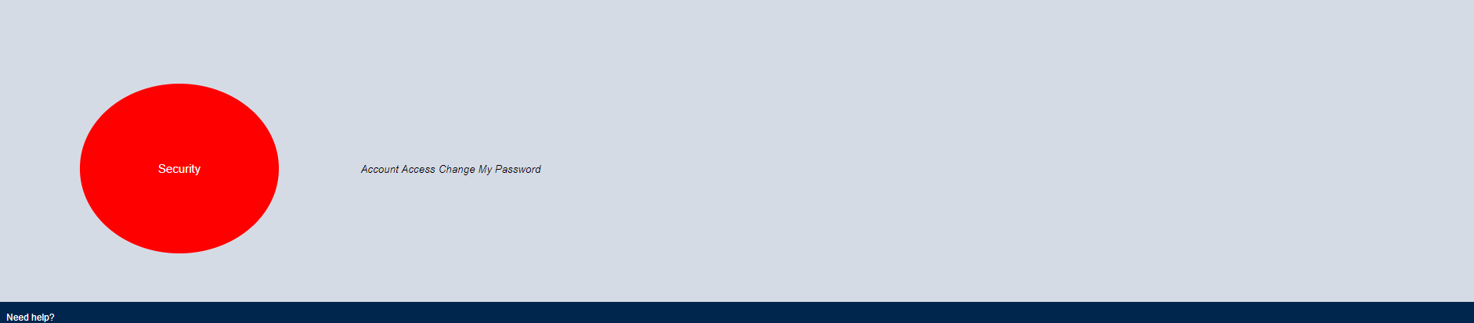

**(HTML)**

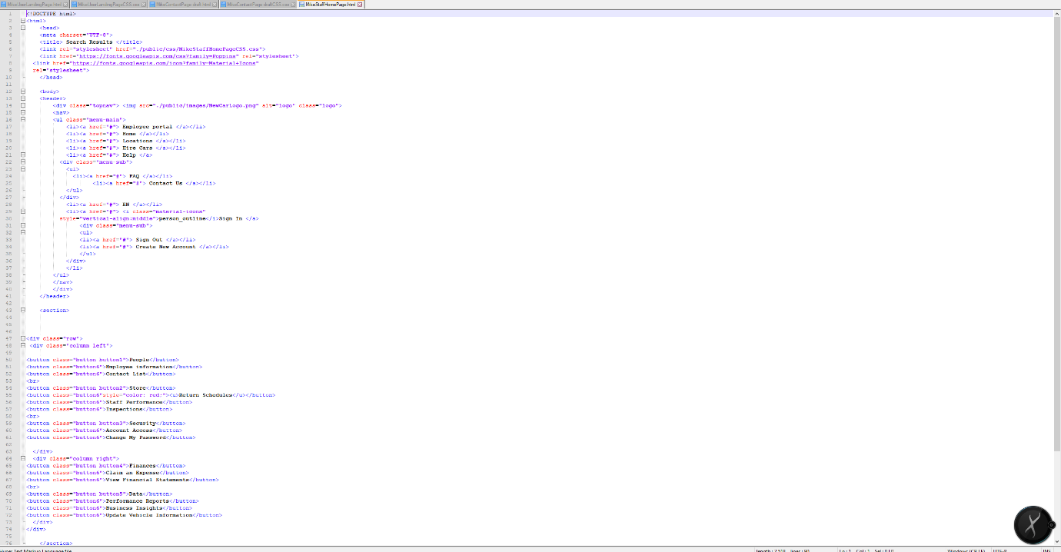

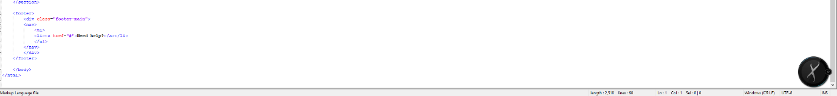

**(CSS)**

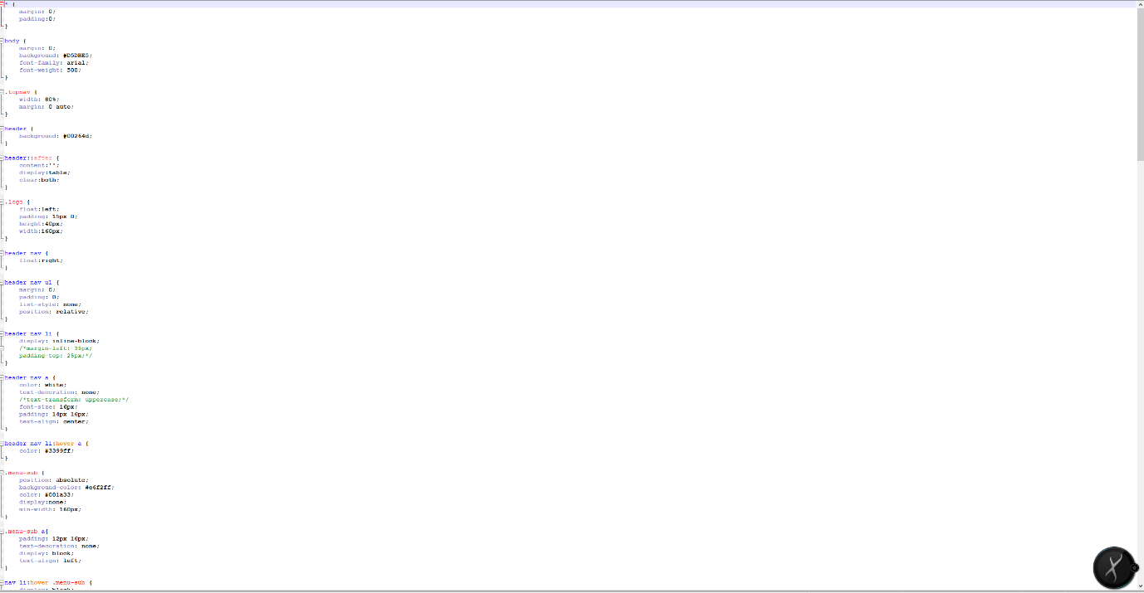

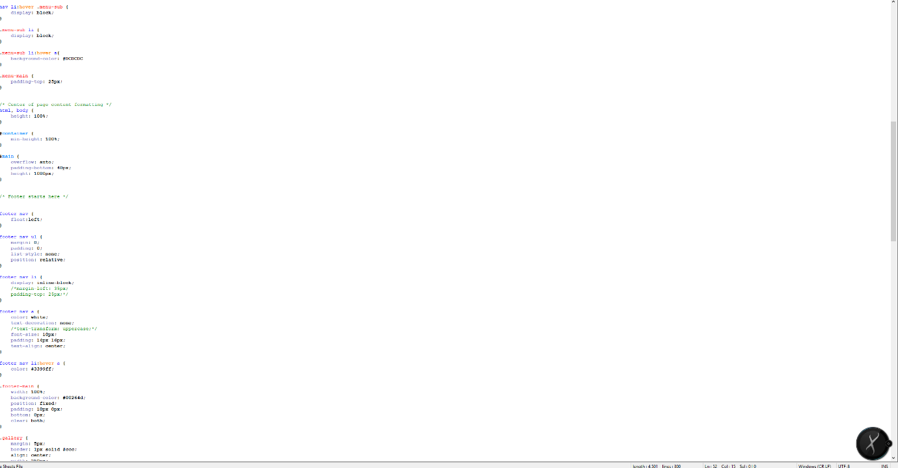

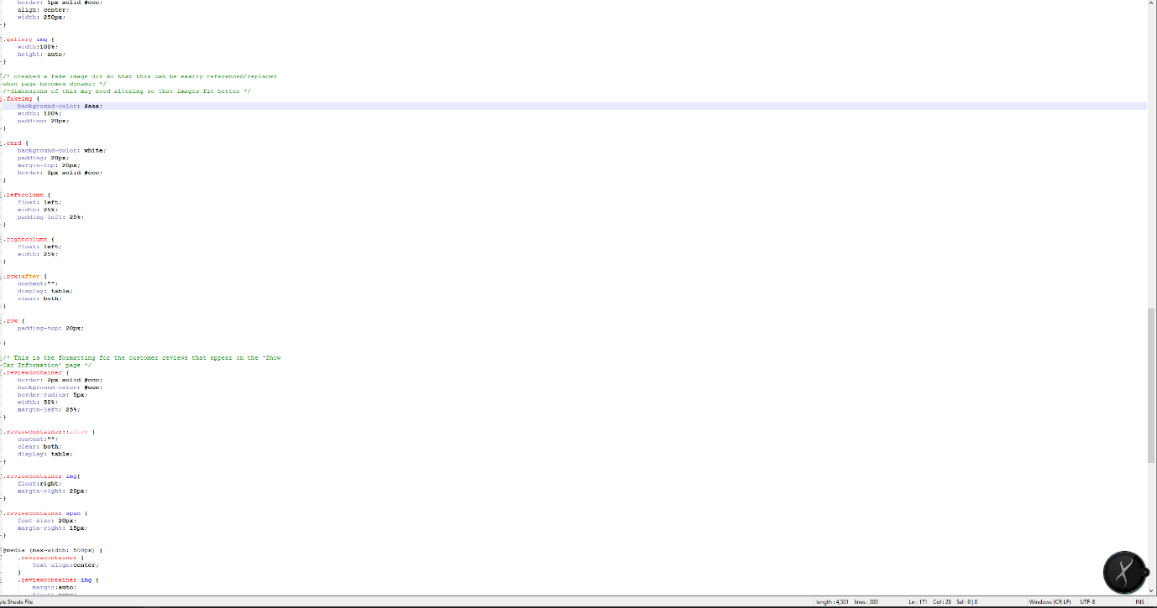

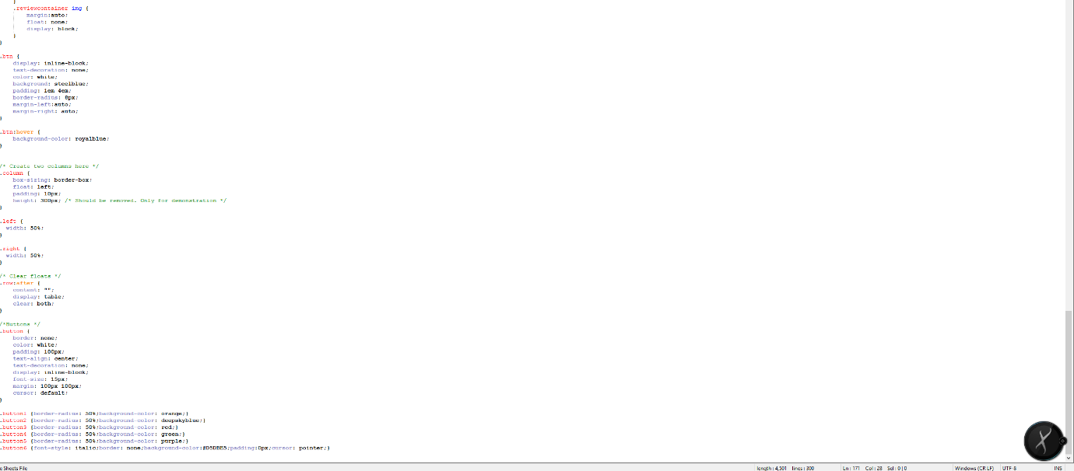

**(Add a staff edit area with textboxes in show car original page which is done by other members. I add a staff edit area, it allows staff access user to access page in a different interface compared with normal user.)**

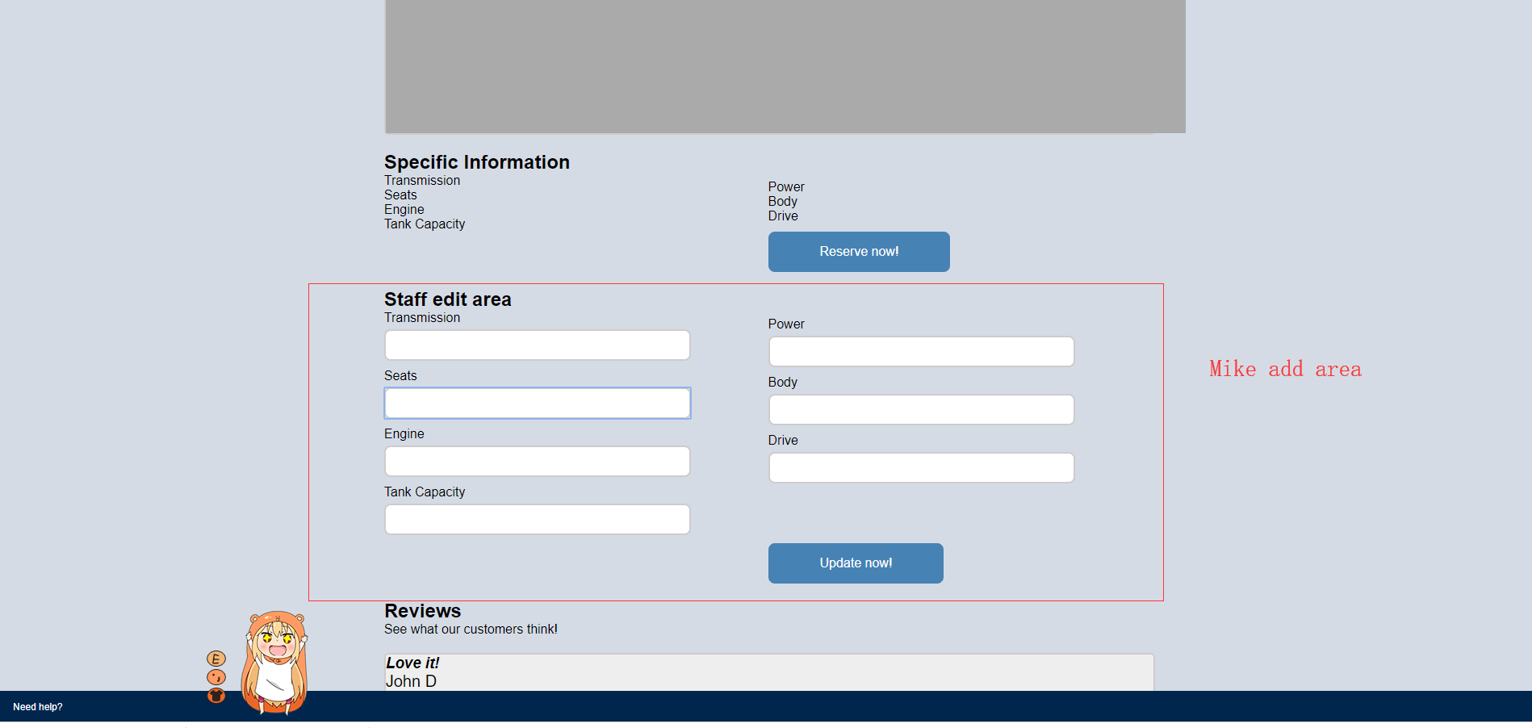

**(html)**

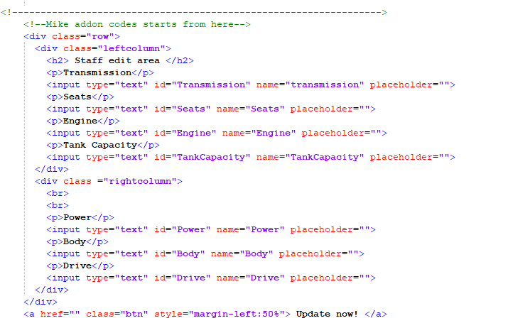

**(CSS)**

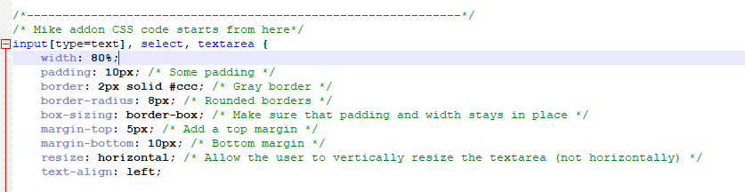

**Artefact 3** – Value Chain diagram – a diagram that lead me to work correctly

**Description about what the artefact is in general**

The value chain is a high-level process that represents an organisation performs so that the company can achieve a business goal correctly.

**Brief description of how it was used/contribution to the project**

In our sprint 2, I want to make sure my work is correct and have a clear purpose so that I can follow the step by step to achieve the goal. The value chain in our sprint 2 became a guideline that leads me to understand my own tasks better.

**Screen capture of where it’s used**

**A close up of a logo

Description generated with high confidence**

**Artefact 4** – The BPMN Choreography diagram which focuses on the interactions between staff access user and normal access user.

**Description about what the artefact is in general**

The BPMN 2.0 choreography diagram represents the interactions taking place between two or more business parties. It acts as a contract and focuses on message exchange between parties. The purpose of the choreography diagram is that in order to understand the relationship between two or more different group of people, at the first, the company must identify how can one group of people contact and communicate with another group of people. Unlike other types of BPMN 2.0 diagrams which focus on the business progress of operating the company, the choreography diagram directly focuses on the communication aspect.

**Brief description of how it was used/contribution to the project**

In our sprint 1, we focused on how we build the website with database implement. Now in our sprint 2, we focused on how to show our website features to the customer. Therefore, we should get a clear understanding of the relationship between CRC company staffs and customer. In order to understand better, the choreography provides me with a clear interaction between “staff access user” and “normal” access user”. This diagram shows every single feature such as search car, edit personal information, it briefly explained what kind of interactions were received by which group of users. From the diagram, as a client who is also a “staff access user”, I understand how I communicate with customer and what the key features of each website are, it creates a significant outcome that when I design and build the website, I can know which part of the website should be the main object which I should put more attention on.

**Screen capture of where it’s used**

**A screenshot of a video game

Description generated with high confidence**

**Artefact 5** – define the normal user’s access ability with our website by creating Petri Net diagram

**Description about what the artefact is in general**

Petri Nets is one of the mathematical modelling languages, it provides a graphical notation for operating processes which include iterations, choices, and concurrent execution. (Murata, 1989) Petri net can reflect a system in a super easy – identify way, it contains only three elements, consisting of places, transitions, and arcs.

**Brief description of how it was used/contribution to the project**

As I mentioned in artefact 4, In our sprint 2, we focused on how we can provide our key features to the customer, the choreography diagram represents the interactions between two different level of people, differently, the Petri nets directly represents what the key features are and how they work for normal users. As you can see in the screen capture area, I have screenshotted a series of steps of user edit information as an example so that this can make sure my diagram has no error and work completed. The purpose that I created this diagram is that if I only know the what the key features are, but I do not know how to deliver them into web functions, the whole website will lose functions, and lake linking elements. Therefore, I created this diagram to make sure every key feature is working completely and linking correctly.

**Screen capture of where it’s used**

**(overview)**

A picture containing object

Description generated with very high confidence

Example step 1 – login

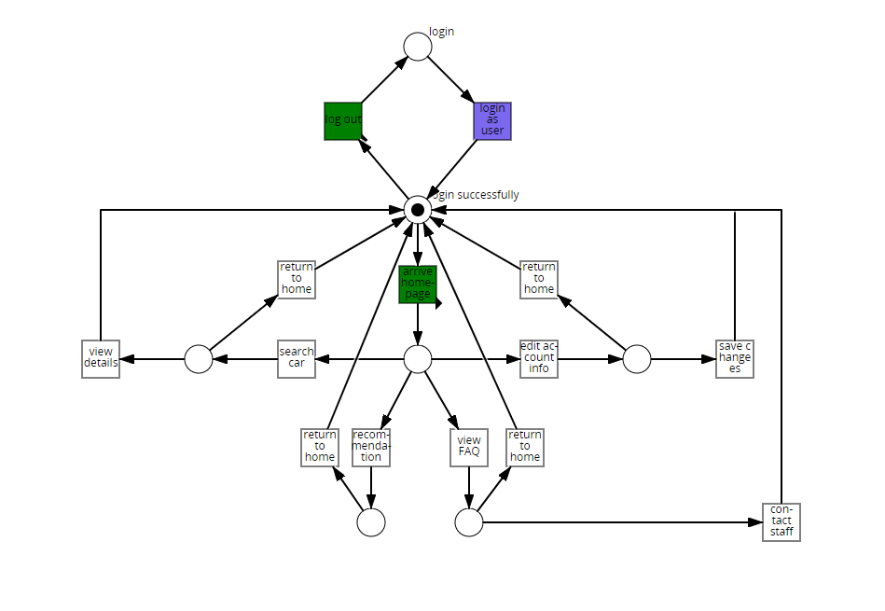

Example step 2 – arrive home page

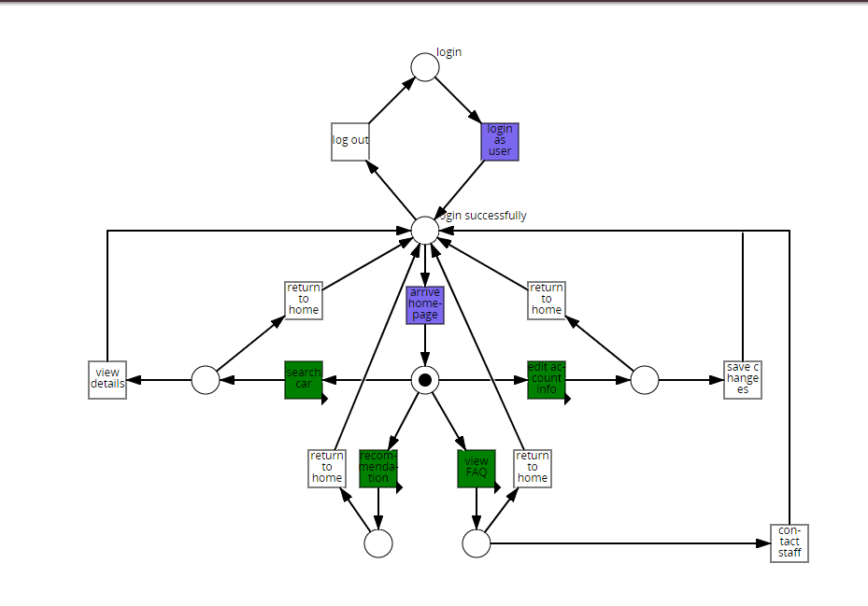

Example step 3 – edit account information

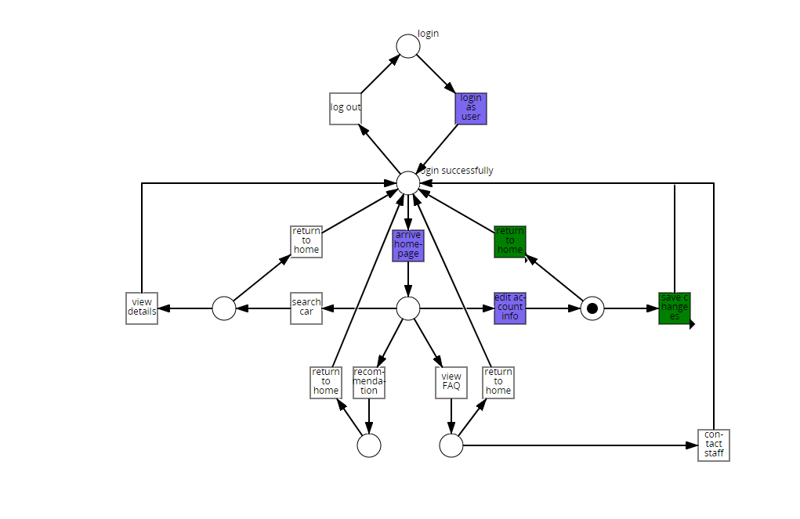

Example step 4 – save changes

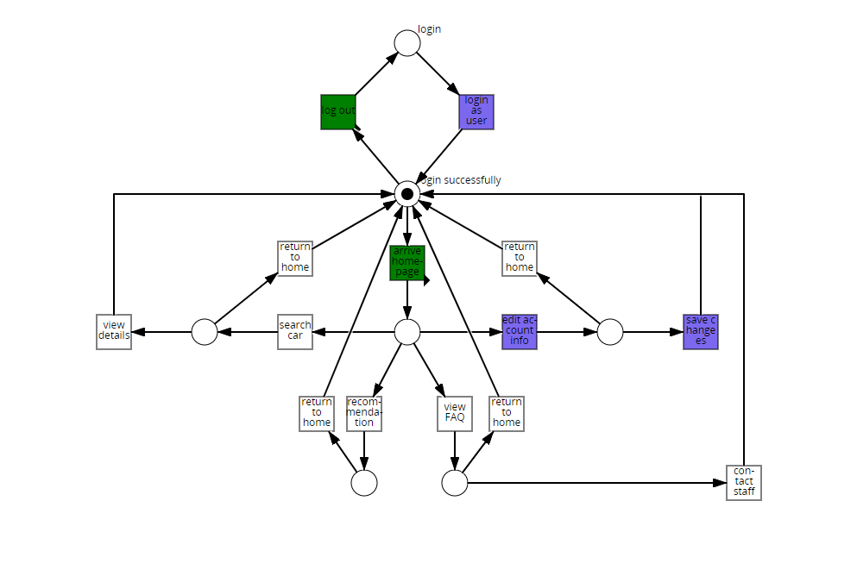

Example step 5 – log out

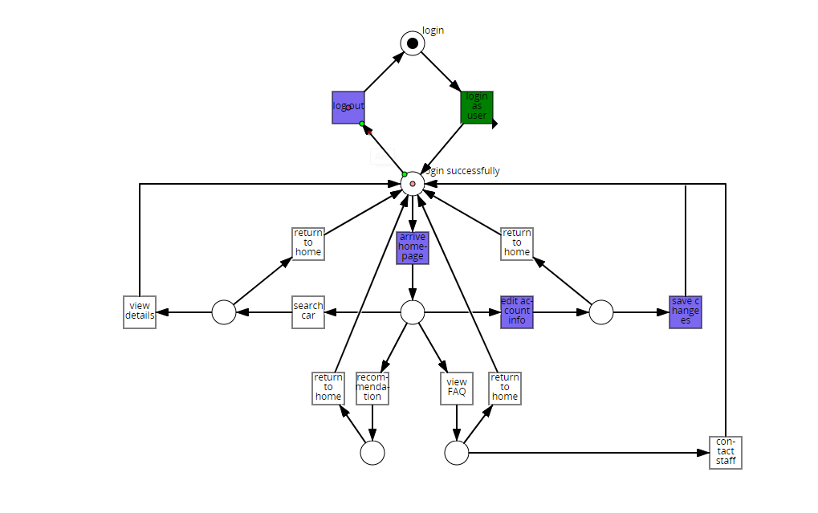

**Reference**

Murata, T. (1989). Petri nets: Properties, analysis and applications. Proceedings of the IEEE, 77(4), 541-580.